2. Split the data using the code below, where set1 will be the training set for future

analyses and set2 the test set:

set . seed (46685326 , kind =" Mersenne - Twister ")

perm <- sample (x= nrow ( vehdata ))

set1 <- vehdata [ which ( perm <= 3* nrow ( vehdata )/4) , ]

set2 <- vehdata [ which ( perm > 3* nrow ( vehdata )/4) , ]

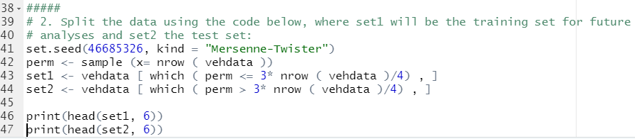

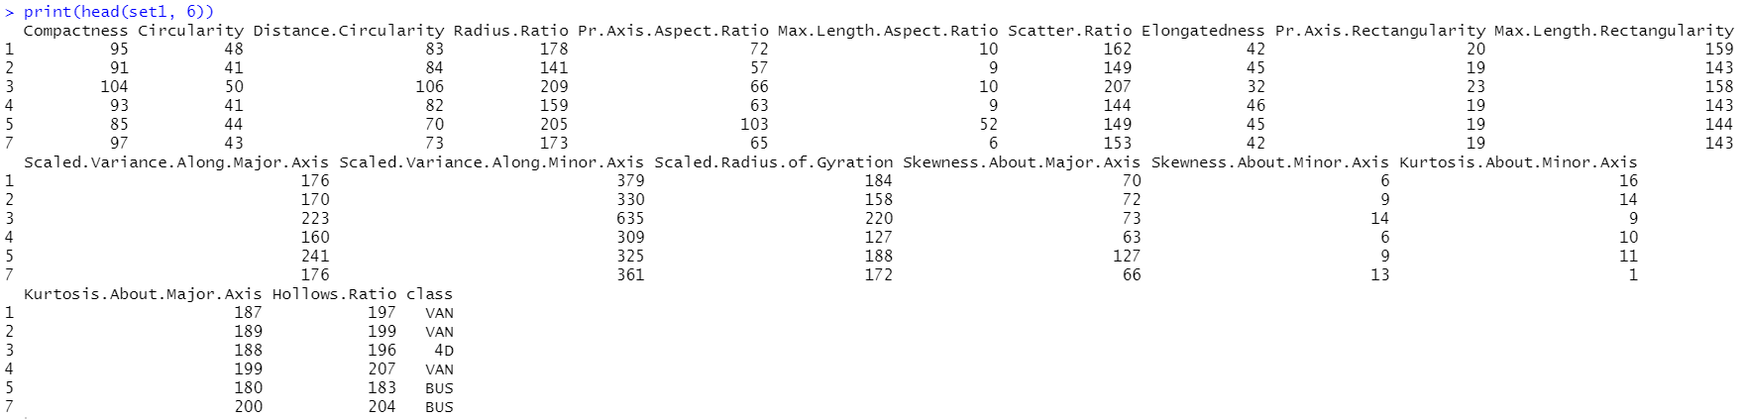

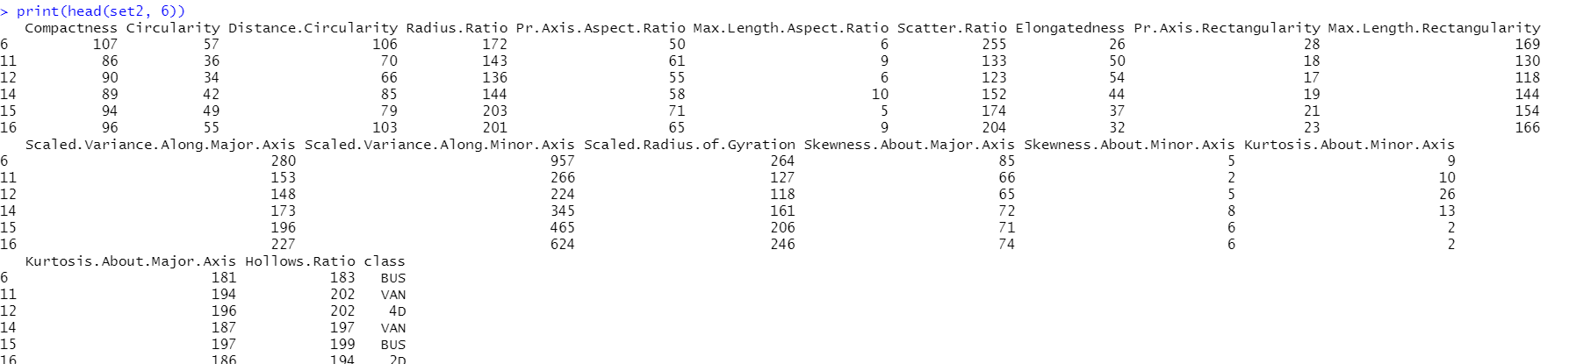

3. Run a KNN analysis on the training data using *m* = 1.

(a) **Show the confusion matrix for the test data. Comment on how well**

**separated the four classes are. In particular, are there classes that are**

**easier/harder to separate?**

(b) Compute and **report the test misclassification rate and approximate standard**

**error.**

